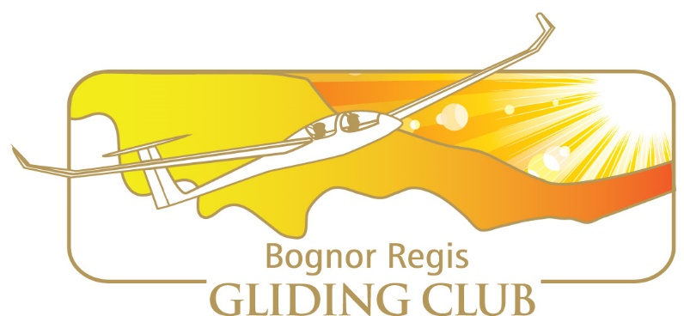

Bognor Regis Gliding Club

Operational Procedures

FORWARD

The purpose of this document is to provide guidance on the operational procedures
relating to Bognor Regis Gliding Club (BRGC). It does not attempt to
capture every instruction, procedure or working practice at the club, but concentrate on the
key elements relevant to gliding operations. (both ground and air).

It will be periodically updated to reflect new & changes in procedures. All updated versions will be published on the BRGC website.

It is the responsibility of every member at BRGC to familiarise themselves with the contents of this document and any updates to it on a regular basis.

Julian Hitchcock

01/03/22

Bognor Regis Gliding Club
Glossary of Terms

AAIB Air Accident Investigation Board. A group within the Department for Transport
responsible for investigating any aviation accident that results in serious injury
or damage to an aircraft.

Airside That area of BRGC field east of the club house.

BGA British Gliding Association. The body in the UK with devolved authority (from
the CAA) for over-seeing the regulation and control of matters relating to
gliding.

BRGC Bognor Regis Gliding Club.

BST British Summer Time.

CAA Civil Aviation Authority. The body in the UK responsible for over-seeing the
regulation and control of all matters relating to civil aviation.

CAP413 The Radio Telephony Operators guide for use of the aviation frequencies.

CFI Chief Flying Instructor.

DI Daily Inspection.

Duty Instructor
An instructor approved by the CFI who undertakes responsibility for the flying
operations taking place.

DVLA Driver and Vehicle Licensing Agency. The group responsible for defining
medical requirements for HGV standard drivers. These requirements have
been aligned by the BGA/CAA with those applicable to glider pilots.

FRTOL Flight Radio Telephony Operator’s Licence.

Launch Marshal
The person who has assumed responsibility for overseeing the initial stages
of the winch and A/T launch including checking “all clear” and conducting the hand and or radio signals.

NOTAMs Notifications to Airmen. The daily instructions outlining areas of restriction and
special temporary rules affecting use of airspace in the vicinity likely to be
flown.

P1 Pilot in command (if flying dual this is usually the Instructor or pilot
holding a Passenger Rating).
P2 Student, visitor or solo pilot receiving a check flight in a two-seater.

QFE Height above the airfield (i.e. with the altimeter set to zero at the launch
point).

QNH Height above sea level.

VFR Visual Flight Rules.

Bognor Regis Gliding Club
Contents

Operational Procedures:
1..BGA Operational Regulations
2. Chief Flying Instructor (CFI)
3. Duty Instructor
4. Duty Pilot
5. Safety and the Safety Officer
6. Requirement to Help
7. Starting the Day
8. Winch Drivers
9. Vehicle Driving
10.Laying Cables
11. Daily Inspection
12. Launch Marshal
13. Cable Protocol
14. New members
15. Making Visitors Welcome
16. Children on the Airfield
17. Dogs
18. Cars on the Airfield
19. End of the Day
20. Medicals
21. Alcohol
22. Local Soaring
23. Length of Flight
24.Circuits
25. Use of Radio
26. Thermalling in the circuit
27. Thermalling Over the Airfield
28. Annual Checks
29.Cloud Flying
30. Aerobatics
31. Passenger Rating.
32. Buying into an Aircraft
33. Cross Country Flying
34. Visiting Pilots
35. Operational Documentation
36. Record Keeping

Appendix 1 – Aerotowing
Appendix 2 – Winch Launching
Appendix 3 – Solo flying when there is no instructor at the field
Appendix 4 – Passenger Rating

Bognor Regis Gliding Club
Operational Procedures

1. BGA Operational Regulations:
All gliding at clubs such as ours in the United Kingdom (UK) is conducted in
accordance with British Gliding Association (BGA) Operational Regulations, which are
detailed in “Laws and Rules for Glider Pilots”. All members must always comply with
these and are strongly recommended to ensure that they always have an up to date
copy of this document. (Which is available from the BGA’s website as a downloadable
document.)
The following sections cover local rules that add to the BGA Operational Regulation
but in no way override them.

2. Chief Flying Instructor (CFI):
The CFI has responsibility for all matters concerning gliding operations. His
decision in flying matters is final. He may appoint rated deputies to carry out his
instructions if absent but remains responsible for all flying matters.

3. Duty Instructor:
No flying can take place unless a Duty Instructor is present on site on the
ground or locally in the air. (Unless operating under Appendix 1) His instructions must be carried out and any pilot not doing so may be grounded and referred to the CFI.

Instructional flight will normally take place between 10.00 to 17.00 with appropriate breaks for the DI (and other instructors).

However, it is up to each instructor to make it known when s/he is available and for how long each day. All instructors must stop instructing when they no longer feel fit to do so.

The first Duty Instructor for any particular flying day is responsible for ensuring the following actions are carried out by him or a nominated club member:
a) That NOTAMs are obtained and checked for any impact on flying operations locally.
b) That meteorological reports are considered for their possible impact
on flying operations.
c) Planning the layout of the field (position of winch, cable run, launch area etc) and
conveying this information to the Duty Pilot.

4. Duty Pilot:
The Duty Pilot acts as the Duty Instructor’s manager on the ground.
We need members to do all of the groundwork and the Duty Pilot’s job is mainly concerned with organising this. To achieve this, his instructions must also be accepted by the other members present on the field. Duty Pilots are therefore expected to report to the Duty Instructor any member or pilot who refuses to carry out a reasonable request.
Wherever practical, he should delegate activities to those members available so that he is free to oversee safe operations. He must equip himself with, and carry at all times, the mobile airband radio and winch radio when appropriate.

5. Safety and the Safety Officer:
ALL MEMBERS are responsible for safety both on the ground and in the air.
Members must be mindful of their own actions and also be vigilant regarding the
actions, or non-actions, of others. If any member observes anything that could affect
his own safety or that of any other person, he must immediately act to
prevent it developing into an incident.
BRGC strongly advises the use of parachutes and energy absorbing cushions which
are provided in all club gliders for all members to use. If any member decides to
remove or not use either of these two safety critical pieces of personal protection
then they do so at their own risk. Flights without energy absorbing cushions and
parachutes are not recommended.

The BRGC Safety Officer acts as a focal point for safety related matters within the
club. Any incident witnessed or experienced by any member must be reported to the
Safety Officer. The Safety Officer is also responsible for investigating and
reporting flying related accidents to the BGA and Air Accident Investigation Board
(AAIB). In addition, he is also responsible for creating operating procedures and
briefings to ensure that potential repeat incidents are avoided.
Our Accident Procedure is located in the clubhouse and available to download on the website, please familiarise yourself with its content should you need to use it in the case of an accident or incident. There is also a Minor Incidents reporting mechanism on the website, which members are encouraged to report anything untoward that occurs on the ground or in the air. The details are forwarded anomalously to the CFI & Safety Officer. These minor incidents are compiled and used to help prevent a more serious incident or accident occurring.

6. Requirement to Help:
The club depends on all members doing all of the work that is needed. We therefore request that any member wishing to fly on a day does their share of work on the ground or around the club.

7. Starting the Day:
At the start of the day, authorised pilots may Daily Inspect aircraft and equipment without an instructor being present.

8. Winch Drivers:

Winch driving is a vital part of the club operations and a role that carries with it great
responsibility.
In addition to providing pilots with successful launches, the winch driver
is an important element in ensuring those launches are conducted safely and
efficiently.
To drive the winch at BRGC you must first be signed-off by the Winch Master and CFI after which you may DI and operate the winch.
The guillotines on the Skylaunch winch must be cleaned, examined and lubricated
every calendar month and given a Full Function Test annually. Pilots trained in the general
operation and DI of the winch are encouraged to take the opportunity to participate in
the guillotine scheduled maintenance, testing/re-setting in order to acquire the
necessary skills. All scheduled maintenance must be recorded on the sheet provided
for that purpose in the winch.

Any work that is done on the winch must be recorded in the book in the winch.
This is so that wear and tear can be monitored and trends of deterioration can be
picked up and acted on.
The winch cables must be inspected each day before flying commences. Any damage, or repair showing excessive wear, or coming together of the ferrules, must be cut out and the cable re-spliced.

9. Vehicle Driving:
Any member who is competent in the operation and use of a vehicle may teach other members how to carry out the tasks required on the airfield.

10. Laying Cables:
When towing out launch cables, the ideal situation is for the vehicle to take an
absolutely straight line from the winch to a point between the two aircraft to be
launched.
When towing out cables the vehicle driver should stop if he sees a glider on approach to avoid any conflict and enable the glider to manoeuvre around the tow out vehicle if necessary.
Pilots are reminded that cables/ropes can get caught on undercarriages and skids so
should plan their approaches so as to avoid the cable runs.
When towing out cables, permission should be requested from the launch point before proceeding to avoid conflicting with A/T taking off.

11. Daily Inspections (D.I's):
Aircraft DI's will be carried out only by pilots who have been trained and signed-off by trainers and examiners approved by the CFI. An entry to that affect must be recorded in the section of their logbook relating to Daily Inspection's.
Persons carrying out the DI must ensure that the glider is equipped with a fully
charged battery, cable release and positive checks completed and that it is clean;
particularly the canopy.
Whilst it is a requirement that aircraft should only be taken out to the launch point
once they have been DI’d, it is the responsibility of the first person to fly the aircraft to
ensure that it has been DI’d (by a qualified person) before it is flown.

12. Launch Marshal:
Once the pilot has accepted the cable being attached to the aircraft, initiation of the
launch passes to a member outside the aircraft nominally designated by the Launch
Marshal. His most important job is to ensure that there is no hazard to launching
which might not be visible to the pilot.

It is absolutely essential that before calling “all clear above and behind” s/he has
positively and methodically checked that this is so. In addition, s/he should also ensure that there are no persons within a 90-degree arc ahead of the glider, paying particular attention to visitors who may be unaware of the dangers associated with glider operations.

Once the launch procedure has started, any member may shout “STOP” at any time
for any reason. In such cases the person stopping the launch should also raise both
hands in the air, the Launch Marshall should radio the winch or Tug STOP, STOP, STOP and the pilot must release the cable. No member must ever be criticised, if it turns out that the “STOP” call was not necessary.

13. Cable protocol (pilots ready for cable):
To avoid slowing the launch rate, particularly in busy periods, pilots & instructors are required to take sensible steps to ensure they are ready for the cable when it arrives. Instructor briefings should be completed prior to getting in the glider to avoid long delays at the launch point.
It must be stressed that no pilot must ever be rushed or badgered into the air or interrupted during their pre-flight checks.
The pilot has a duty not to delay operations except for reasons of safety.

14. New members:
All members are asked to do everything they can to welcome new members and
help them to get involved by showing them how to carry out the ground operations.

15. Making Visitors Welcome:
Please make all visitors feel welcome and ensure that all visitors are accompanied by a member “airside”. If interested please provide verbal and written information about the club and offer to show them the hanger or accompany them to the launch point.

16. Children on the Airfield (Under 16)
Children are not allowed on the airfield unless under the control and supervision of an adult.
Airfields can present several hazards that children in particular may not be aware of,
or are more susceptible to as a consequence of immaturity or distraction. For
example:
• Gliders are very quiet and it is often impossible to hear them approaching.
• Gliders can land on the airfield from any direction.
• Winch or A/T cables are hard to see and can drop virtually anywhere on the airfield.
(This list is not exhaustive and these are only some of the examples. They also
are equally applicable to adults but it is reasonable to assume that children are
more vulnerable for the reasons stated above).

17. Dogs
Dogs are not allowed on the airfield unless kept on a lead at all times when flying is taking place.

18. Cars on the Airfield
The normal and safest place for cars is outside of the airfield in the Sainsburys or Pub car parks. Approved Cars should only be taken airside if there is a good reason to do so. Examples of good reasons include the following:
• Towing a glider to and from the launch point;
• Recovering a glider having landed on the airfield;
• As a means of conveying visitors to and from the launch point;
• In the event of an emergency requiring urgent use of a vehicle.
Drivers should question whether or not they have a legitimate and justifiable reason for taking their car airside.
If cars are taken airside, then the doors must be left unlocked with the keys in the
ignition so that members can move the vehicle in the event of an emergency.
Drivers who take their vehicles airside must bear in mind that they do so at their own risk and that their own insurance is probably invalid. BRGC will accept no
responsibility for damage incurred by a private vehicle airside.

19. End of the Day
It is the responsibility of the Duty Instructor and the Duty Pilot to oversee the
activity necessary at the cessation of flying operations. On days, when no
Duty Pilot is officially assigned, it is the responsibility of all members present to undertake this activity jointly.
All gliders should be logged down reporting details of any unaccounted gliders (club
and private) to the Duty Instructor.
All ground equipment must be returned to the appropriate areas.
All club gliders that have flown during the day should have any accumulated mud
washed off, paying particular attention to the wheel boxes. They must then be
returned to the hangar and the doors closed.
Prior to this, the Duty Pilot must ensure that all club parachutes are put in the
parachute bags in the clubhouse and that all club glider batteries and radio's are put on charge.

20. Medicals:
It is the responsibility of all solo pilots to ensure that they have a valid medical at all
times.
The BGA guidelines state that all clubs have a duty to assist their members to comply
with the requirements and to maintain appropriate records and documentation.
The Annual Return form includes a declaration relating to medical status and must be
completed before the CFI revalidates individual cards. This provides the CFI with a
written record of when the next medical declaration renewal is due. The onus remains
on individuals to ensure that their own declaration is obtained and either the original
or a copy provided to the CFI in order to maintain club records.
Instructors must not send a pilot on his first solo without first establishing that he has
a valid medical declaration. Abinitio (pre solo) pilots must ensure that they obtain a
medical declaration during their training and present it to the CFI who will then
endorse their training record card accordingly.
If a pilot does not hold a valid and current medical declaration then he cannot fly as
P1. Similarly, it is up to all pilots to take account of temporary medical conditions that
may prevent them from flying safely (e.g. colds, fatigue, stress, hangovers). In such
circumstances they should either not fly or fly only with an instructor. They should
also make known relevant details of any incapacity (temporary or otherwise) to the
Duty Instructor on any occasion when they might wish to fly.
Similarly, if a pilot develops a chronic or potentially long-term medical problem they
should inform the CFI and seek the advice of their GP, or consultant, as to the effect
this might have on the legitimacy of their current medical declaration and fitness to fly.
Use the GASCo I’M SAFE checklist.

21. Alcohol:
Even the most moderate drinker should be aware that the Railways & Transport
Safety Act makes it an offence for pilots, including glider pilots, to fly whilst over the
prescribed limit for alcohol.
This regulation could be interpreted as being applicable, in the event of an accident,
to anybody involved in flying operations – winch driver, wing tip holder, etc.
The limit is (breath) 9 micrograms per 100 millilitres or (blood) 20 milligrams per 100
millilitres. Note that this is a quarter of the equivalent drink/drive limits and is,
effectively, a zero tolerance limit. A law has existed for many years that pilots must
not fly whilst impaired through drink or drugs. The Railways & Transport Safety Act
quantifies the limits and provides a statutory testing regime.

22. Local Soaring (pre cross-country endorsement):
Pilots who do not have the Cross-Country Endorsement to their Bronze Badge are
restricted to local soaring.
At BRGC, this is defined as not more than five nautical miles from the airfield and
always within gliding range.
Gliding range is defined as having sufficient height to arrive back over the field at
1,000ft without having to find lift on the way.

23. Length of Flight (club aircraft):
When flying a club single-seat aircraft, the flight should normally be restricted to a
maximum duration of one hour unless briefed/authorised otherwise by the Duty
Instructor or Duty Pilot. A typical reason for extending it would be for a Cross-
Country Endorsement or Silver Duration attempt declared prior to the flight.
When flying a club two-seater, flights would normally be for no longer than 45 minutes
but this can be varied at the discretion of instructors dependent upon demand and
availability of instructors. Trial lesson flights should typically be no more than 30 minutes.

24. Circuits:
“Normal” circuits should be started no lower than 700-800ft and should generally correspond to the launch-point in use on any given day. However, glider can and do land in any direction on the field. Pilots who have started their circuit should therefore be aware of the possibility of conflicting traffic.
The preferred glider circuits are RH to the east for RWY 05 and RH to the west for RWYs 23 and 19

25. Use of Radio:
Use of radio in the air is not compulsory at BRGC but is strongly encouraged as it assists flight operations and safety. Full guidance on the use of radios in the air is
included in CAP413. A copy of this is available via the CAA website.

The call sign for air operations is “BOGNOR TRAFFIC”.
Downwind calls can be made as a useful guide to others but all pilots must be mindful
of the fact that many aircraft fly without radio.
Pilots using any frequencies other than those allocated for gliding or emergency, must
ensure that they have a valid FRTOL.
For ground operations a civil radio is used to communicate between the launch-point, winch and cable retrieve vehicle.

26. Thermalling in the circuit:
Thermalling, once having joined the circuit, is discouraged unless the location of all likely traffic is known.
Once having joined the circuit it is impossible to be certain that there is no other glider
behind you. An aircraft that is behind you will reasonably assume that you are going
to fly a more or less normal circuit and if that aircraft then starts to thermal, the trailing
aircraft can be put in a very difficult position.
This can be dangerous, particularly if the pilot of the second aircraft is a low-hours
solo.

27. Thermalling Over the Airfield:
Other thermalling over and near the airfield is permitted subject to good airmanship
being demonstrated. This includes thermalling off the wire, even if this delays the next
launch. In such cases it is the responsibility of those on the ground to ensure no
further aircraft are launched until it is safe to do so.

28. Annual Checks
All solo pilots must undertake check flights. This will vary according to experience from daily to annual checks.
These must include a general flying check, spin and stall recovery (A/T) and simulated emergencies. These checks must be satisfactory and completed each soaring year and signed off by the instructor undertaking them.

In the event that a pilot fails a check then they must undertake the check again and
pass it before the instructor can sign it off.

If a solo pilot has not completed their annual check flights they will not be allowed to fly solo until those checks have been successfully completed. (Unless agreed by the CFI)

29. Cloud Flying
Cloud flying is not permitted within five nautical miles of the airfield.
Cloud flying from BRGC is permitted beyond five nautical miles provided the pilot
meets the following conditions:
• S/He has received training in instrument flying including recovery from unusual
attitudes.
• S/He has a parachute.
• S/He has a working turn and slip or artificial horizon. The glider must also have a
back-up battery supply in the event of the failure of the primary power source.

30. Aerobatics
Aerobatics must only be flown by pilots who have had appropriate training and, in a glider, rated for those aerobatic manoeuvres intended to fly. No aerobatics must be started below a height of 2,000ft and the aircraft must never drop below 1,500ft whilst doing them, unless approved by the CFI.

(Stalling & Spinning is not classed as an aerobatic manoeuvre but must not be started below 1500ft.)

31. Passenger Rating (see Appendix 4)
Passenger flying may only be done by pilots with a P1 rating signed by the CFI.
It must be stressed that no pilot has an automatic right to this. It is entirely at the
discretion of the CFI. Full details on the privileges, requirements and responsibilities
associated with the Passenger Rating are included at Appendix 4.

32. Buying into an Aircraft
All pilots must inform the CFI of their intention to buy and fly an aircraft new to them at
BRGC. The CFI must agree it is appropriate to their skill level before it is flown by them.
All pilots must ask permission of the CFI before bringing a new aircraft on site.

33. Cross Country Flying
Suitably qualified pilots (i.e. those who hold the Cross Country Endorsement) are
encouraged to fly cross-country from BRGC.
All pilots must tell the Duty Instructor of their intention to fly cross-country and record
their flight plan before take-off.
Before flying it is essential that the pilot checks the day’s NOTAMs and is fully aware
of any activity or restrictions that could affect his intended flight.

34. Visiting Pilots
Visiting glider pilots are welcome at BRGC but must familiarise themselves with
these Operations.
Before flying, they must make themselves known to the Duty Instructor who will
decide (based on their level of experience, qualification and currency) their flying
status on the day.

35. Operational Documentation
Club aircraft manuals (e.g. Pilot Operating Manuals, Technical Manuals, Certificate of
Airworthiness documentation) and BGA Manuals are located in the clubhouse or the website and are available for all members to peruse. Pilots wishing to convert to a club aircraft that they have not flown before should familiarise themselves in particular with the
Pilot Operating Manual and or talk to an instructor.

36. Record Keeping
All logbooks (including electronic) shall be kept up to date and periodically certified (Signed during annual checks) as being correct by the CFI or his nominated deputies.

Appendix 1

Aerotowing

****************** IN WORK ******************
Appendix 2
Winch Launching:

The resources on this page have been put together as part of the BGA Safe Winch Launching Initiative. We hope that all glider pilots will make use of this to increase their knowledge of winch launching – and of what can go wrong. By doing this, everybody can contribute to our efforts to maintain the improvement in safety seen in the first nine years of this BGA initiative.
The information presented here builds upon the messages from the earlier stages of the initiative. Accidents resulting from stalls and spins following power loss during the launch (cable break, winch failure etc) have declined dramatically – but we all need to remember the earlier advice:
- after take-off, maintain a shallow climb until adequate speed is seen with continued acceleration. Then allow the glider to rotate at a controlled pace. If power is lost near the ground, immediately lower the nose to the appropriate recovery attitude.
- after a power loss in mid-launch, adopt the recovery attitude, wait until the glider regains a safe approach speed, and land ahead if it is safe to do so.
Cartwheeling accidents – predominantly to experienced pilots – are still happening as a result of not releasing the cable if the wing drops during the ground run.
- If you can’t keep the wings level before take-off, release before the wing touches the ground
- At BRGC this translates to: If I can’t keep the wings level before take-off I will release. (As the time it takes to react will mean the wing will probably touch down before you release)
Be familiar with the BGA Safe Winch Launching available on the BGA Web.
Recommended winch setup below:
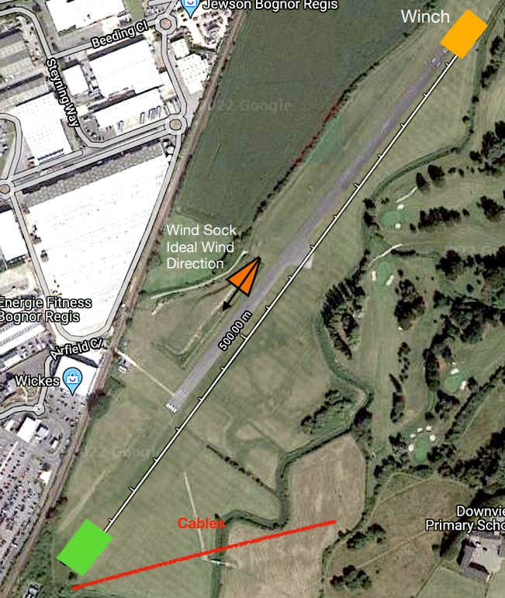

Appendix 3

Solo Flying Operations if there is no Instructor Available to Supervise

Aerotow only
Tug pilot decides when flying starts and stops

Solo glider pilot must have:

Silver C (with CFI endorsement)

Power, Self launch / motor glider flying is permitted
(as these pilots are self regulating)

- Weather limits
- No flying if wind is in excess of (or gusting)15knts
- Visibility must be greater than 3mls
- Minimum cloud base 2,000ft
- (All Aerotows must be below cloud base)

Prior to Flying:
NOTAMS must be checked

Email to CFI to confirm above prior to flying taking place

Appendix 4 – Passenger Rating

General
Only one pilot can exercise his or her Passenger Rating during a single flight (i.e. this is not mutual flying so it must be clear to both crew who is the P1 before the glider is launched).
Pilot Requirements
Requirements:
- Approval by CFI
- Valid Medical,
- Bronze C, LAPL (s) or PPL
- 10hr solo in the last year (Gliders)
- Completion of check flight(s) with CFI to include:

Circuit planning
Stall recovery
Eventualities
Oral air law test / when to fly decision discussion

Prior to undertaking P1 flight:
- Have completed above / annual check flight with CFI (Rating signed off in log book)
- Have the agreement of the Duty Instructor on the day of the flight.
- Be current on 2 seater's, (At least 3 take off and landings in last 90 days)

The flight:
- All of the flying is to be done by the P1 from the front seat and no instruction can take place.
- P2 must NOT be a paying passenger.

